

Year 9 Science
Physics 1 Test: Heat Transfer and Electricity

SECTION 1: MULTIPLE CHOICE (1 mark each)
Circle your answer on the multiple choice answer sheet.

- Heat moves through space by the process of
  - conduction
  - convection
  - radiation
  - magnetism

- Convection currents occur due to thermal expansion and differences in density. Convection transfers heat through
  - solids only
  - solids and liquids
  - liquids and gases
  - gases and empty space

- Convection currents cause
  - sea breezes
  - movement of magma within the Earth’s crust
  - global weather patterns
  - all of the above

- Electric current is the movement of
  - protons
  - electrons
  - neutrons
  - positrons

- Electric current is measured in
  - joules
  - energy
  - voltage
  - amperes

- The potential difference or ‘push’ a battery gives to energy in a circuit is measured in
  - joules
  - watts
  - volts
  - amps

- An object with strong positive nuclei that attracts electrons and stops them from moving through it is
  - a conductor
  - an insulator
  - a battery
  - a metal

- Electrons are small negatively charged particles. Electrons accumulate when a synthetic substance is rubbed against a non-synthetic substance. This results in
  - static electricity.
  - current electricity.
  - heat.
  - radiation.

- How difficult it is for an electron to move through an object or circuit is known as
  - resistance
  - joules
  - voltage
  - amperes

- Which of the following is the most effective electric insulator?
  - metal
  - wood
  - gold
  - water

- A material which easily allows electricity or heat to move through it is called
  - an insulator.
  - a conductor.
  - a resistor.
  - a circuit.

- Which of the following statements about electricity is true?
  - V = I ÷ R
  - Resistance slows down the flow of electrons and is measured in ohms.
  - Voltage is the rate of flow of electrons and is measured in amperes.
  - Amplitude pushes electrons and is measured in amps.

- Which of the following shows two globes in parallel?
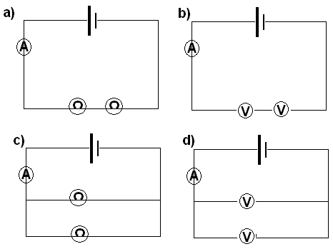

.

- A voltmeter is being used to measure the voltage drop across a speaker. Which of these diagrams shows the correct way to use a voltmeter?
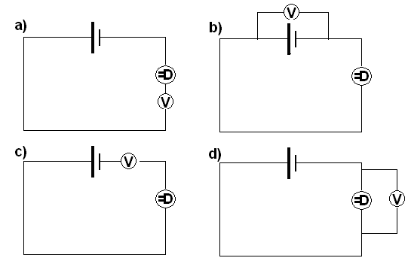

- The circuit diagram below shows how a house would be wired.
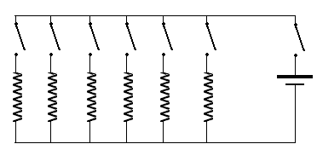

The advantage of this kind of wiring is
- If one appliance is switched off, they all switch off.
- If one appliance is switched off, you can still use others.
- The voltage is divided between each of the appliances, so no one appliance gets too much electricity.
- The current is constant all the way around the circuit, so there is always plenty of power for any appliance.

SECTION 2: WRITTEN
Write your answers on the lined paper provided. Show All Working.

- What do each of the following circuit symbols represent? (8)

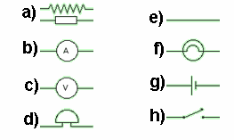

- Draw a circuit diagram for a torch with two batteries. (3 marks)

- Describe the similarities and differences between an electric motor and a generator.
(3 marks)

- What current passes through a lamp of resistance 60 Ω as a voltage of 15 V is applied across it? (Show all working) (3)

- A fuse will blow when a current of 8 A flows through it. If the voltage is 240 V what is the lowest circuit resistance possible before the fuse will blow? (Show all working) (3)

END OF TEST (OUT OF 35 MARKS)

